**Adjustable Mannequin v1.2**

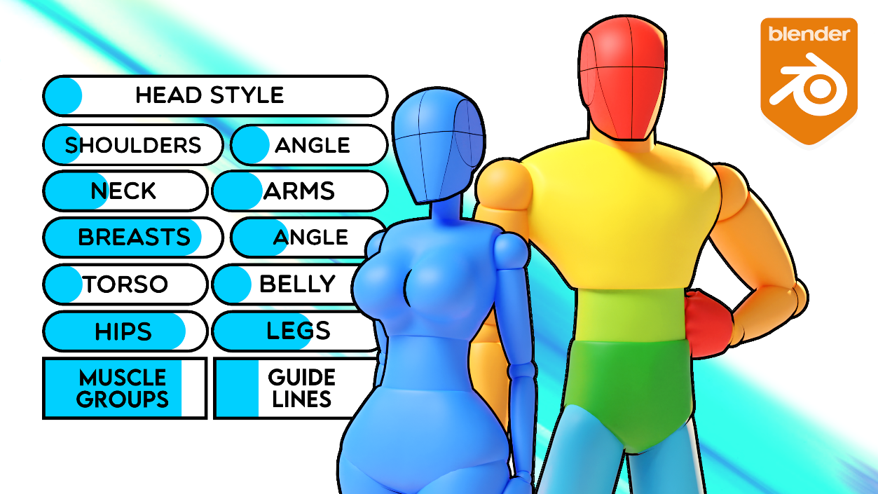

This is version 1.2 of my Adjustable Mannequin. It allows you to dynamically control the proportions of a mannequin using sliders and the rig. You can simply move the sliders and pose your character for pretty nice results, or you can get more advanced and start modifying the rig and mesh directly. I use this for all of my character models and it’s a quick and easy way to get a nice base mesh to start sculpting.

*New in v1.2: Simplified and organised the menu, added more control for the angle of the breasts, added sliders to control the muscle group and guidelines textures, and also modified all of the shape keys to allow for much bigger characters. Some values can now be moved to the left to make certain parts thinner/smaller*

In the folder you’ve extracted, you’ll also see a ***blender_assets.cats*** file, and this is how Blender stores its Assets, so if you ever move the Blender file, you’ll need to move this asset file as well

**Documentation**

When you first open the attached Blender file, you’ll see the adjustable mannequin. You can click on the rig (any of the bones, or the menu) and enter Pose Mode. From here you can play with the sliders and start moving the rig. (Moving the rig using Blender’s move tool **G**).

I made a very simple IK rig, so you can grab the hands, hips or feet and the arms and legs will move accordingly.

[You can watch the video walkthrough here](https://www.youtube.com/watch?v=B2xJCZHdae4)

**These are the main steps that I would take to use this model:**

* **Play with the sliders and rig** until you have the pose and proportions that you like or select from one of the character presets in the Asset Library.
* In Object mode, select your model and press **Ctrl+A** and Apply **Visual Geometry to Mesh**. This will remove all of the shape keys
* Then you can **apply the armature**, play with proportions further if you need to and Remesh under the Object Data tab
* Then **in Sculpt mode, smooth out all of the joints** and now you have a custom base mesh that you can start adding detail to

**Pose Library – Pose Presets and Character Presets**

In v1.2 I’ve added some **character presets using Blender’s Pose Library**. In the **Asset Browser** you can go to the Catalog **AM Presets or AM Poses** and you’ll see all of the pose presets.

In Pose Mode, with **nothing selected you can then double click on any of the character presets** and it’ll change the rig and model. You can also **Right Click on any of the presets and choose Blend Pose** and this will allow you to blender between the poses, so you could have 50% Mario and 50% Peach for a character halfway between the two.

You can also select certain bones or parts of the body and then the character preset will only affect the selected areas, so you could take the slider settings from one character, or just the legs or body.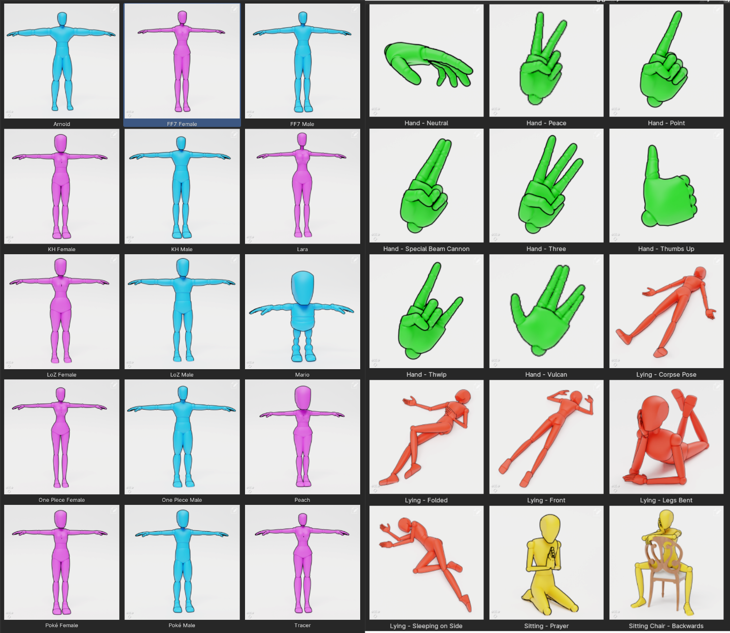

Character Presets.

**Creating Custom Presets**

IF you wanted to create your own character preset, you can do it fairly easily.

Open up the Dope Sheet and change it Action Editor. In here, create a new action by clicking the New button. Then right click on the Shield icon and click Mark as Asset.

Now all you have to do is create your character by moving the sliders and rig and when you’re finished, we can go to the Rig Tab on the right and select both the Rig and Sliders Bone Collections.

We don’t want to keyframe the Menu because then the menu will move around when we change presets.

So with all of those bones selected, press I and Keyframe all of the bones.

I like to choose Whole Character (Selected Bones Only).

Now just press the X icon beside the name of the Action.

This will allow us to modify the bones, otherwise the model would always reset to this pose.

You can always open it back up by clicking the little menu icon, but if you want to animate or create a pose, just make sure to press the X button

Now back in the Asset browser if you go to the Unassigned section you’ll see your preset!

You can drag this into the AM Presets folder and then it’ll show up with the rest of them.

Now we just need to give it a nice Image, and the materials and lighting are already setup, so you can just Render, save your image, and then you can use that image for your preset.

***IMPORTANT****: If you want the Pose Presets to show up in other files you’ll need to add the Adjustable Mannequin file as an Asset Library in the Preferences*

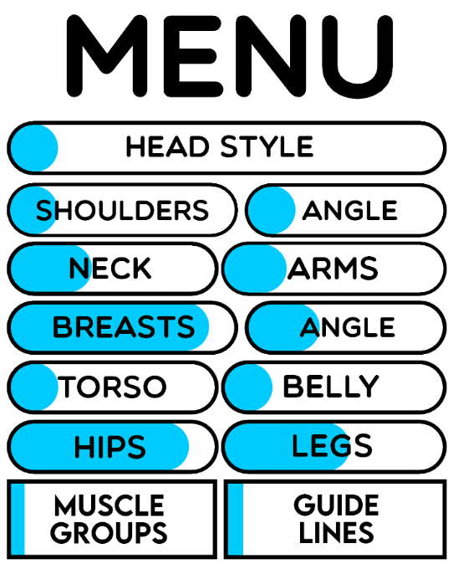

All of the Adjustable Mannequin parameters

**Head Style**

* The Head Style slider controls the design of the head. By default, the mesh uses a Loomis head which is a very popular base head shape for artists. By turning the slider up, the head changes to a more realistic proportioned head.

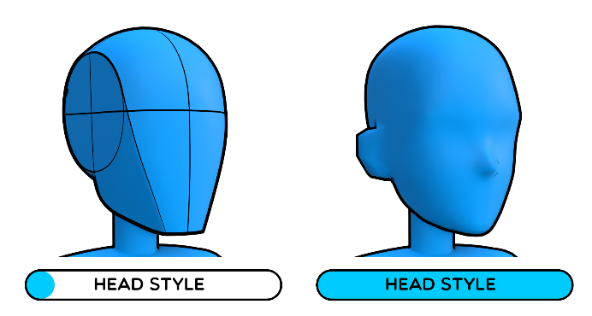

* The Head Style slider allows you to choose a more traditional head model

**Shoulder Width**

* The Shoulder Width slider controls how wide the shoulders are. It actually moves the shoulder bones so you might need to move the hands to fix any IK problems.

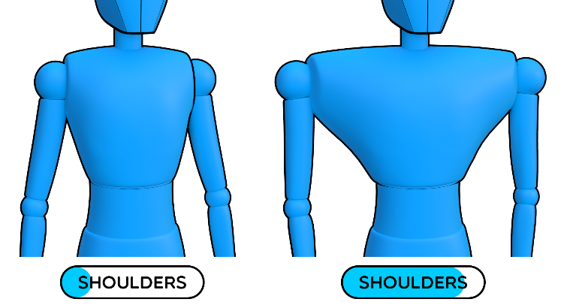

* The Shoulder Width slider controls how wide the shoulders are

**Shoulder Angle**

* The Shoulder Angle slider controls the shape of the shoulders. This is to emulate the bulky Trapezius muscles that you see on a lot of strong characters. Using this in combination with the shoulder and neck controls can allow you to create some very strong looking characters.

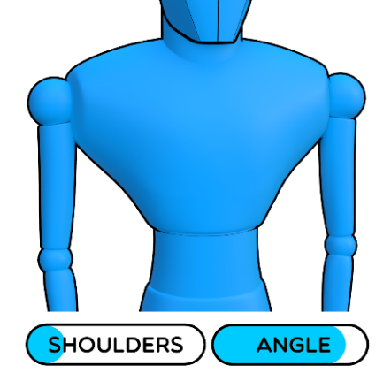

* The Shoulder Angle slider controls the shape of the shoulders

**Neck**

* The Neck slider controls how wide the neck is. This is useful for creating more masculine characters in combination with the shoulder controls.

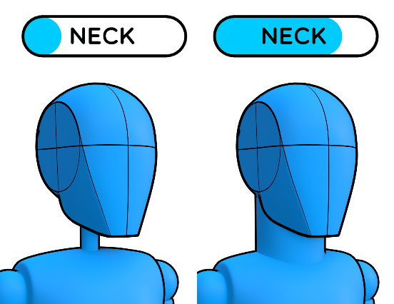

* The Neck slider controls the width of the neck

**Arms**

* The Arms slider controls the size of the arms.

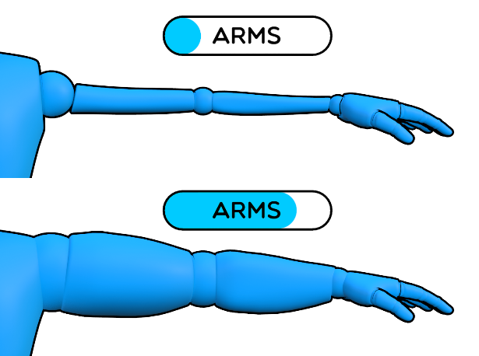

* The Arms slider controls the size of the arms

**Breasts**

* The Breasts slider controls the size of the breasts.

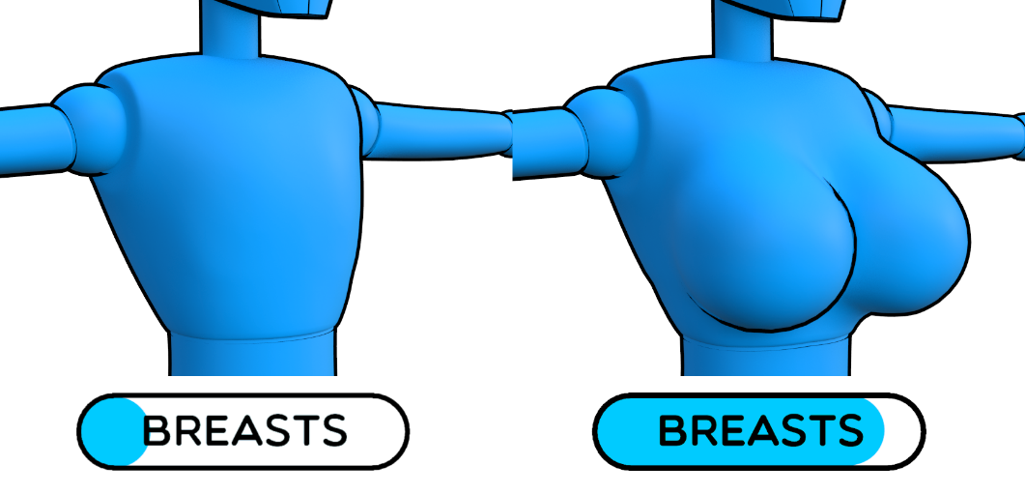

* The Breasts slider controls the size of the breasts

**Breasts Angle**

* The Breasts Angle slider controls the angle of the breasts

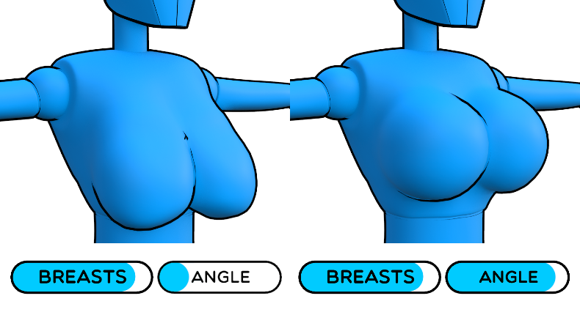

* The Breasts slider controls the size of the breasts

**Torso**

* The Torso slider controls how wide the torso is. This is useful in combination with the shoulder or belly controls to create bulky characters.

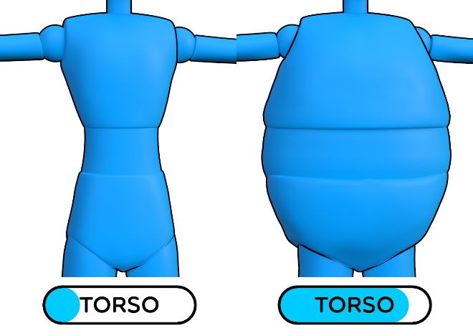

* The Torso slider controls how wide the torso is

**Belly**

* The Belly sliders controls the size of the belly. Use this in combination with the torso controls to create heavier characters.

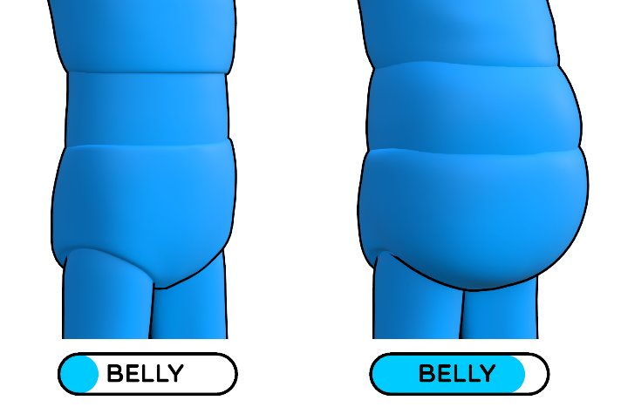

* The Belly slider controls the size of the belly

**Hips**

* The Hips slider controls the width of the hips. This is useful in combination with the Legs control to create more feminine characters.

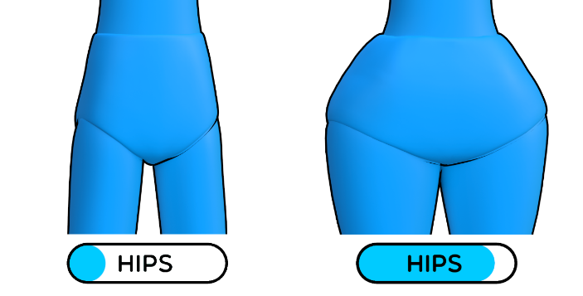

* The Hips slider controls the width of the hips

**Legs**

* The Leg slider controls the size of the legs

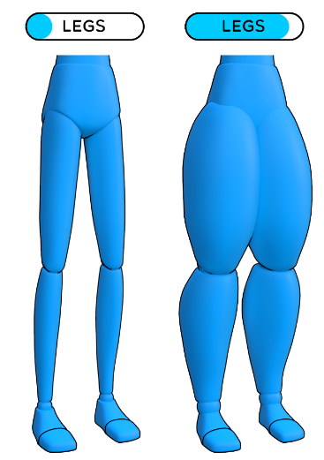

* The Leg slider controls the size of the legs

**Muscle Groups**

* The Muscle Groups slider allows you to enable a Muscle Group texture so you can easily distinguish different parts of the body, which would be useful for drawing.

**Guide Lines**

* The Guide Lines slider enables a texture with reference lines all over the body showing you center lines for each body part, again, useful for drawing.

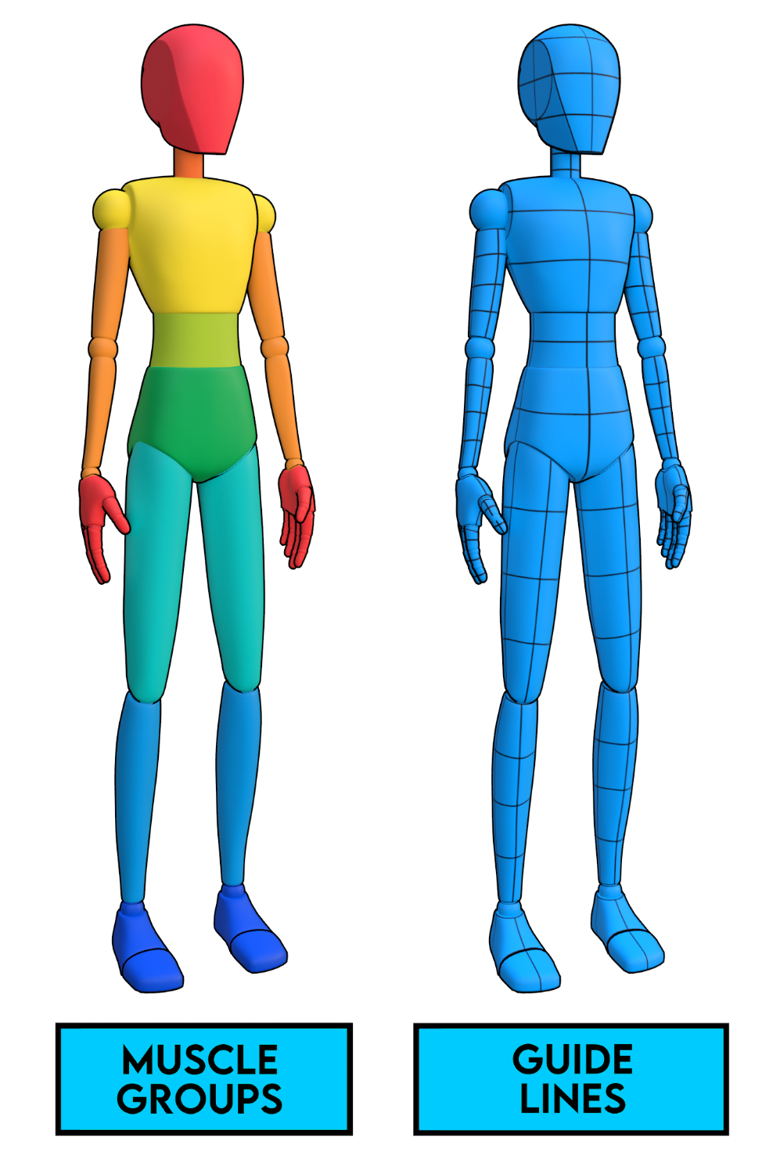

* The Hips slider controls the width of the hips

**Tips**

* If you want to create **multiple characters in one scene, you’ll need to duplicate both the rig AND mesh,** and then you can adjust them independently.
* **You can move, rotate and scale the menu** by selecting the Menu UI in Pose Mode
* You can easily manipulate the rig in whatever way you see fit by moving and scaling things until it fits your design. E.g. you can scale the hips in to make them thinner, then scale the chest bone up to make it regular size again.
* If you want to create some more fantasy style characters that have multiple limbs, you can easily do this by duplicating the rig and mesh, deleting the parts of the body that you don’t need and then just moving the extra limbs into place. Now you have 2 separate rigs, but for this kind of thing you would probably want to go back later and create a custom rig with all of the controls that you need.
* When posing characters, and specifically hands, if you **choose Individual Origins, select all of the fingers of the hand and press R and X twice. This will rotate the finger bones along their local X axis, and it’s a very quick and easy way to create natural hand poses**
* To rotate the arms/legs to get the elbow/knee to point where you want, just **select the upper arm/leg bone and press R the**n Z. This will rotate the bone along the Z axis and it’s a nice easy way of pointing the elbows/knees exactly where you want